Week 1 Task: Understanding Financial Data
Exploratory Analysis of Banking-System Indicators
Public source: World Bank World Development Indicators (WDI)

1. Executive Summary
This report analyzes three publicly available financial-system indicators from the World Bank World Development Indicators: bank capital to assets, bank nonperforming loans (NPLs) as a share of gross loans, and domestic credit to the private sector provided by banks as a percentage of GDP. A 15-country analytical sample was constructed to compare major developed economies and emerging markets. The work covers data acquisition, cleaning, descriptive statistics, comparative exploratory data analysis, correlation analysis, visualization, and interpretation.
The sample shows substantial cross-country variation. Bank capital to assets ranges from 4.07% in Japan to 13.73% in Saudi Arabia, while NPL ratios range from 0.46% in Canada to 5.31% in the United Arab Emirates. Private-sector credit ranges from 26.56% of GDP in Mexico to 194.17% in China. Within this selected sample, capital-to-assets and private credit have a Pearson correlation of approximately -0.60. This is an exploratory association, not evidence of causation, because the sample is small and observation years differ.

2. Dataset and Data Acquisition
The underlying dataset is publicly available through the World Bank WDI. The three indicators were selected because they represent complementary dimensions of financial-system condition: capitalization, asset quality, and credit depth. The bank capital indicator is sourced from Financial Soundness Indicators; the NPL indicator measures nonperforming loans relative to total gross loans; and the private-credit indicator measures bank-provided credit to the private sector relative to GDP.
For this Week 1 submission, a 15-country analytical sample was assembled from the public source series. The latest available observation for each country/indicator was retained and the observation year was stored explicitly. This prevents the report from implying that all observations are from one common year. The included Python script also demonstrates reproducible acquisition from the World Bank API.

3. Data Dictionary
Indicator | Meaning | Unit
Bank capital to assets | Bank capital and reserves relative to total assets | %
NPL / gross loans | Nonperforming loans relative to total gross loans | %
Private credit by banks / GDP | Domestic credit to the private sector provided by banks relative to GDP | % of GDP

4. Data Cleaning and Preparation
- Country names and ISO3 codes were standardized and retained as separate fields.
- Financial indicators were stored as numeric values for statistical analysis and visualization.
- Observation years were retained separately for every indicator because the latest year varies across countries.
- Duplicate rows were checked; the supplied analytical file contains one record per country.
- Missing values were checked after sample construction; all three indicators are populated for all 15 selected countries.
- No interpolation or fabricated values were used.

5. Exploratory Data Analysis
Descriptive statistics for the 15-country analytical sample:
Indicator | Mean | Median | Minimum | Maximum
Bank capital / assets (%) | 8.12 | 7.75 | 4.07 | 13.73
NPL / gross loans (%) | 2.17 | 1.73 | 0.46 | 5.31
Private credit / GDP (%) | 84.67 | 75.62 | 26.56 | 194.17
The capital-to-assets ratio has a mean of 8.12% and a median of 7.75%, indicating meaningful but not extreme dispersion. NPLs average 2.17%, while the range from 0.46% to 5.31% shows substantial differences in reported asset quality. Private credit is the most dispersed measure, averaging 84.67% of GDP and ranging from 26.56% to 194.17%.
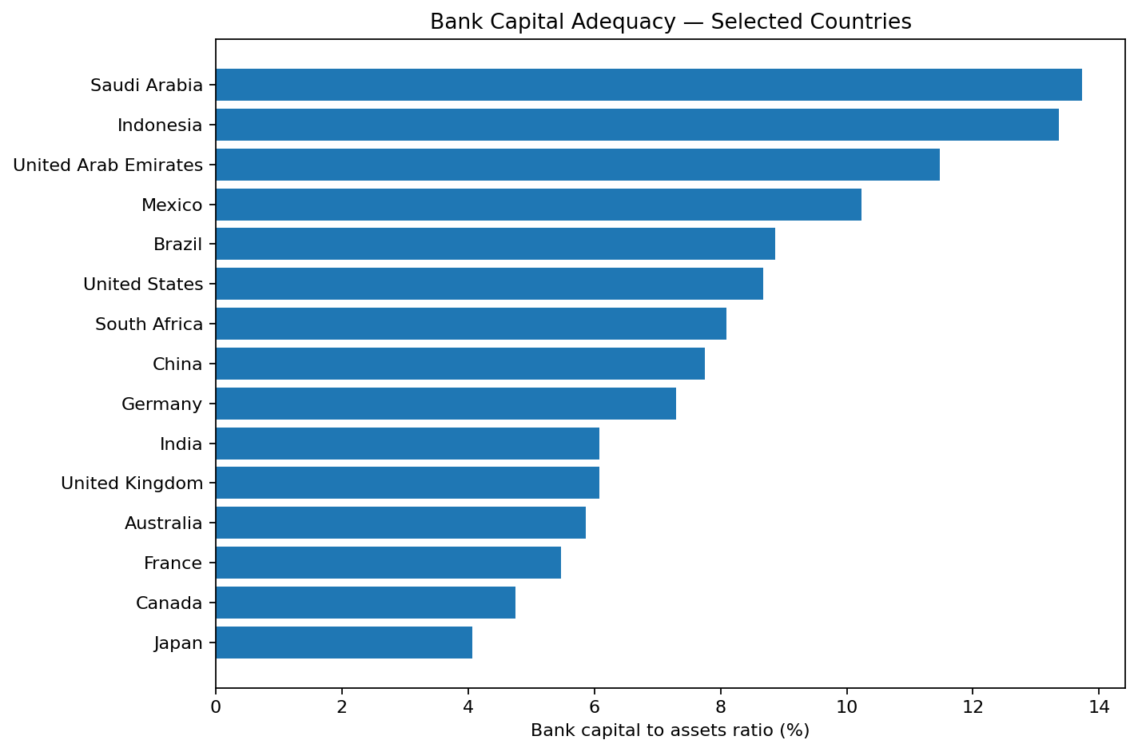
Figure 1. Bank capital to assets ratio for the selected countries.
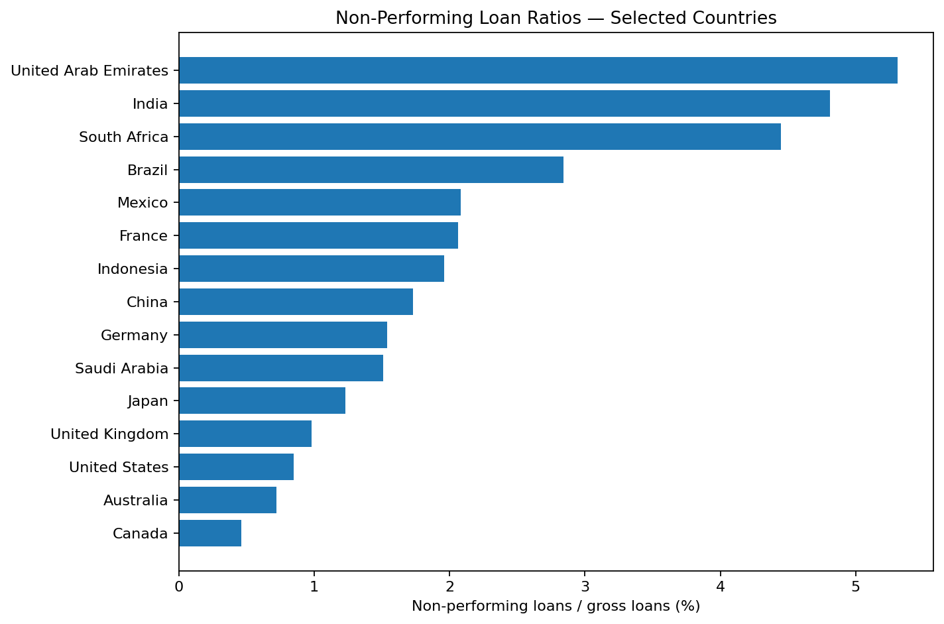
Figure 2. Nonperforming loans as a percentage of gross loans.

6. Comparative Findings
Capitalization differs materially across the sample. Saudi Arabia (13.73%), Indonesia (13.36%), and the United Arab Emirates (11.47%) are among the higher-capitalized markets, while Japan (4.07%), Canada (4.75%), and Australia (5.86%) are at the lower end. A higher capital-to-assets ratio can provide a larger accounting buffer against losses, although it is not a substitute for risk-weighted regulatory capital measures.
NPL ratios show a different pattern. The United Arab Emirates (5.31%), India (4.81%), and South Africa (4.45%) have relatively high reported NPL ratios in this selected group, whereas Canada (0.46%), Australia (0.72%), and the United States (0.85%) are much lower. Cross-country comparisons should consider differences in definitions, supervisory practices, and reporting conventions.
Credit depth is particularly high in China (194.17% of GDP), Australia (129.32%), Japan (123.13%), and Canada (124.10%, with the source's latest available observation shown as 2008). Mexico (26.56%) and Indonesia (31.79%) are at the lower end. This demonstrates why the observation year should remain visible in the dataset.
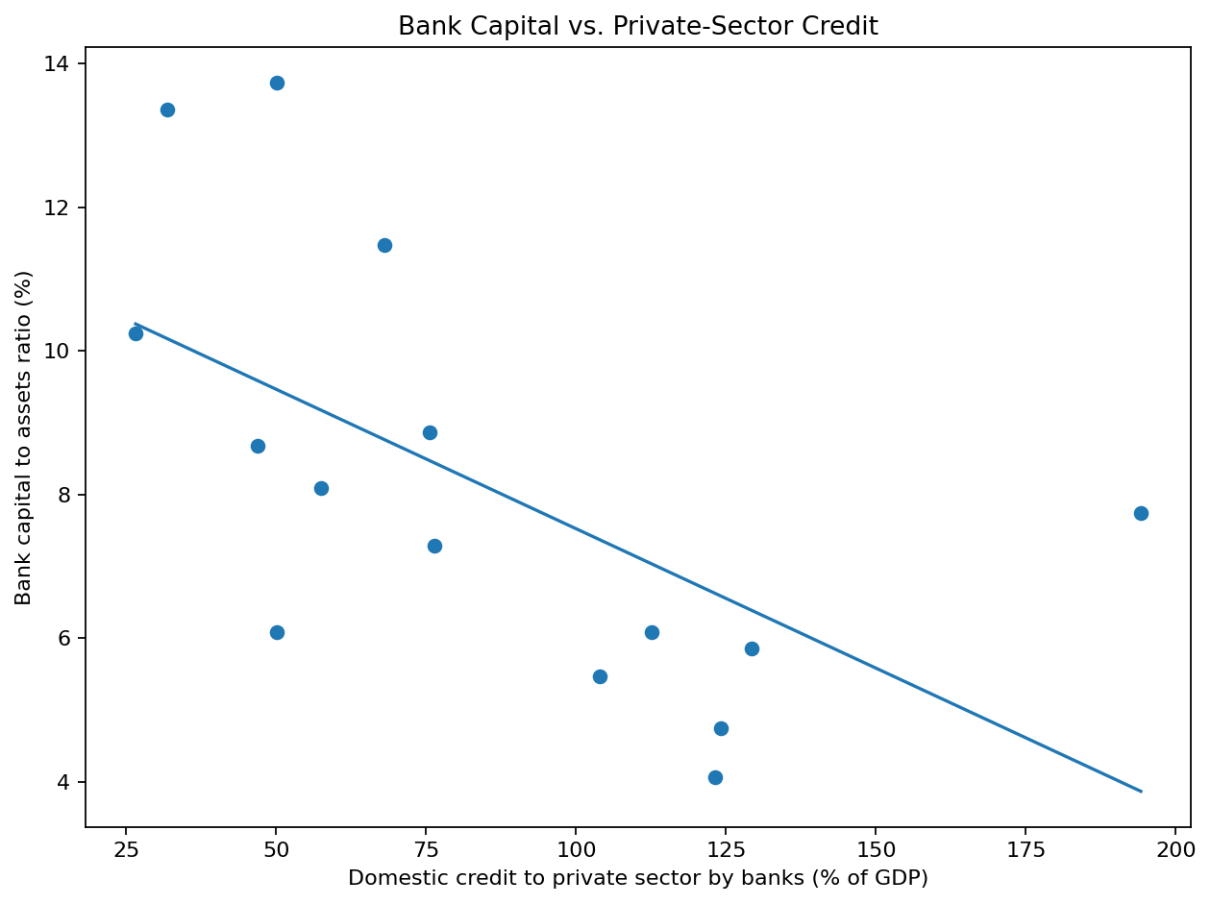
Figure 3. Exploratory relationship between bank capital and private-sector credit depth.

7. Correlation Analysis
The Pearson correlation between bank capital to assets and private credit to GDP is -0.60. The correlation between NPLs and private credit is -0.38, while the correlation between capital and NPLs is 0.25. The negative capital-credit association is the strongest relationship in this small sample. It should be treated as descriptive only: the indicators come from different years for some countries, and financial-sector outcomes are influenced by regulation, macroeconomic conditions, bank business models, and other factors not included here.
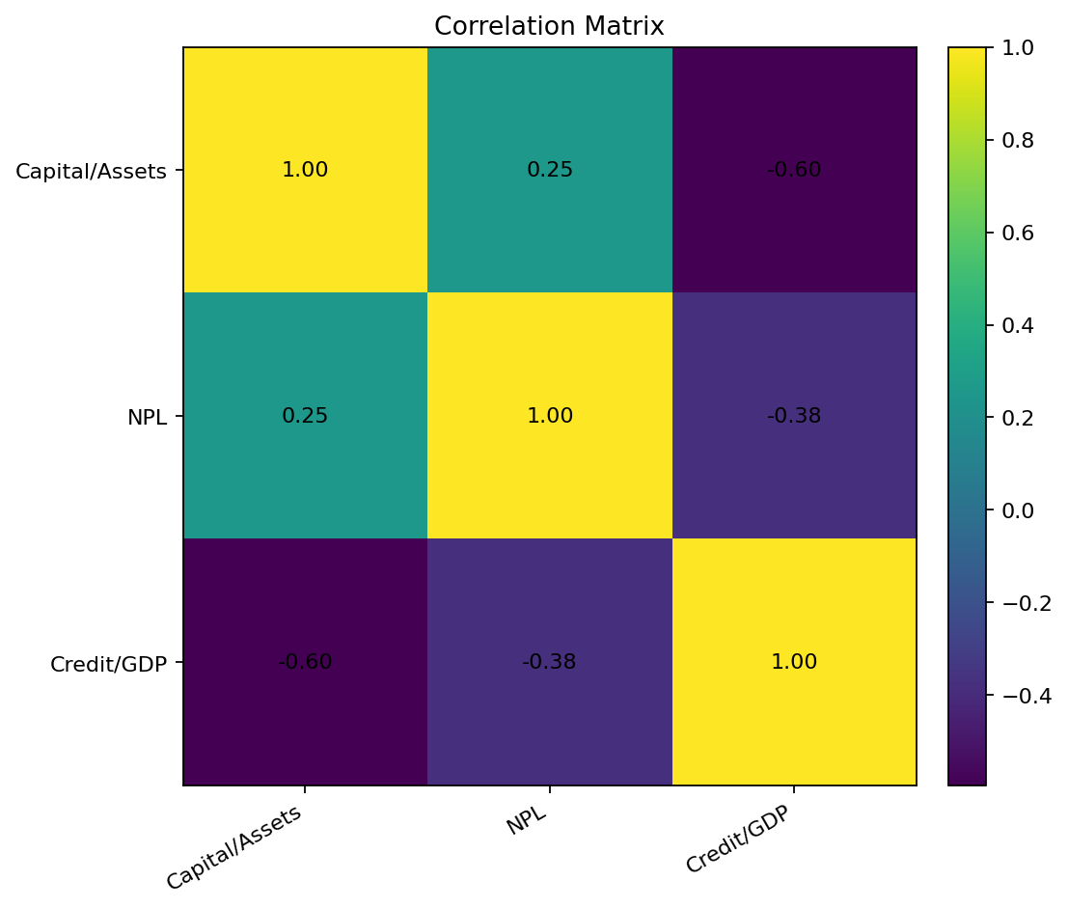
Figure 4. Correlation matrix for the three selected indicators.

8. Key Insights
- Financial-system health cannot be summarized by a single metric; capitalization, asset quality, and credit depth provide different information.
- Higher bank capitalization does not automatically correspond to lower NPL ratios in the selected sample.
- Very deep private-credit markets can coexist with lower aggregate capital-to-assets ratios, highlighting differences in banking-system structure.
- India has an NPL ratio above the sample mean and a capital-to-assets ratio below the sample mean, making it a useful candidate for deeper time-series analysis.
- Observation-year differences are a major analytical limitation and should be resolved before causal or investment conclusions are attempted.

9. Limitations and Next Steps
The main limitation is that this is a 15-country analytical sample rather than the full WDI country panel. The latest available observation year also varies by country and indicator. The correlations therefore should not be interpreted as a same-year panel regression or a causal relationship. A stronger follow-up would download the complete historical WDI series, align common years, quantify missingness, compare regions, and analyze changes around major financial shocks. Additional indicators such as bank return on assets, lending rates, inflation, GDP growth, and stock-market depth could also be incorporated.

10. Sources and Reproducibility
Primary source: World Bank World Development Indicators.
- https://data.worldbank.org/indicator/FB.BNK.CAPA.ZS
- https://data.worldbank.org/indicator/FB.AST.NPER.ZS
- https://data.worldbank.org/indicator/FD.AST.PRVT.GD.ZS
- https://www.worldbank.org/en/publication/gfdr/data/global-financial-development-database
The project folder contains a CSV, Python script, notebook, requirements file, README, and the four report charts. The Python script uses the public World Bank API, converts returned observations to numeric values, removes null/duplicate records, retains the latest available observation for each selected country and indicator, and generates the EDA outputs.

